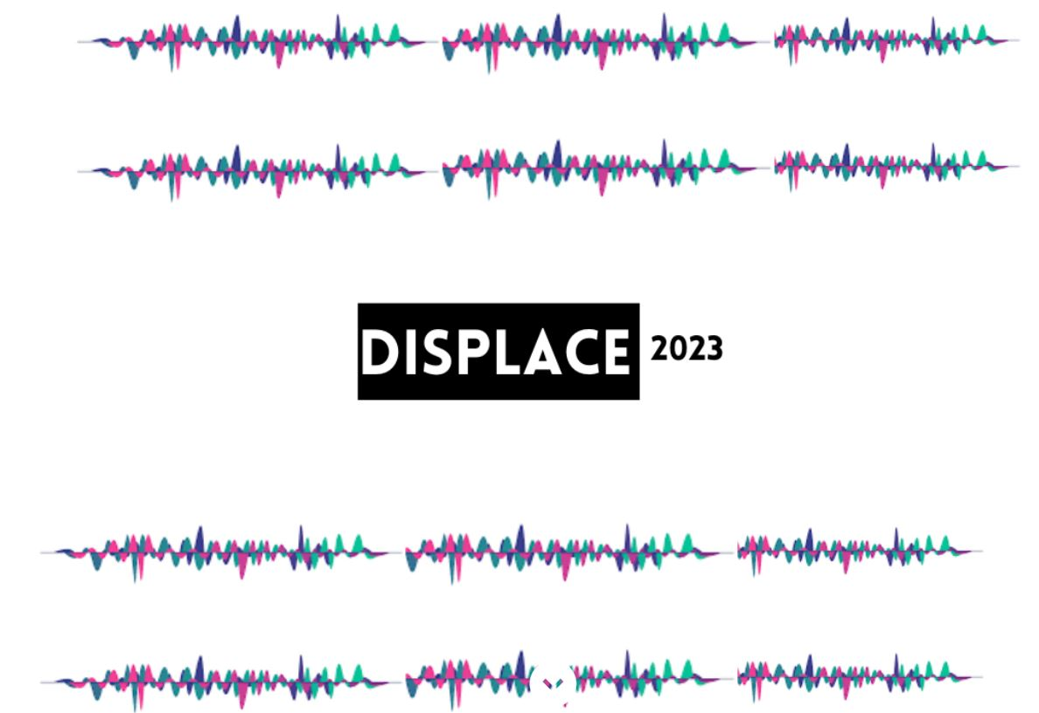

**Terms and Conditions**

**Track-1:**

 Speaker Diarization in multilingual scenarios.

* The goal is to perform speaker diarization (who spoke when) in multi-lingual conversational audio data, recorded in far-field settings.
* You will be provided with a dev audio dataset, and a baseline system to enable design of your own models.
* Subsequently, a blind evaluation dataset will be provided.
* You will submit your model predictions (in rttm format) on the blind set and the validation lists to a leaderboard interface (setup in Codalab). The leaderboard features the performance of all teams on the same dataset.
* The performance metric for evaluation will be Diarization Error Rate (DER).
* All participants will be required to submit a system description report (2-4 pages) to the organizers. All participants are also encouraged to submit their findings to the DISPLACE challenge, Interspeech 2023 for peer-review.
* The participating teams are encouraged to use any open datasets for training and developing the diarization systems.

**Track-2:**

 Language Diarization in multi-speaker settings.

* The goal is to perform language diarization in multi- speaker conversational audio data, recorded in far-field settings.
* You will be provided with a dev audio dataset, and a baseline system to enable design of your own models.
* Subsequently, a blind evaluation dataset will be provided to all participants.
* You will submit your model predictions (in rttm format) on the blind set and the validation lists to a leaderboard interface (setup in Codalab). The leaderboard features the performance of all teams on the same dataset.
* The performance metric for evaluation will be Diarization Error Rate (DER).
* The participating teams are encouraged to use any open datasets for training and developing the diarization systems.

3. The designed system should be automatic, without any manual intervention.

4. Participants can choose to work on any or both the tracks, and are encouraged to submit their findings as a paper to the DISPLACE challenge at Interspeech 2023. These papers will go through the peer-review process of Interspeech 2023.

5. The team must mention sources of any other data used in the system reports for Track 1 and Track 2 (and also in the Interspeech paper)

6. Any future use of data in research and development must give a proper reference to this DISPLACE dataset.

7. The data is provided as described in the Displace dataset description document under the terms of the MIT license (https://github.com/displace2023/Displace23/blob/main/license.md). As a best practice, we encourage you to include the same license file in your developed software.

8. Any form of redistribution of data in Tracks 1 and 2 will require consent from the organizers.

9. The organizers are not liable for any derivatives obtained from this data.

10. The organizers reserve the right to cancel the team’s participation if any violation is brought to notice.

11. The team identity will be coded as anonymous by the organizers in any future publications summarizing the findings of the challenge.

I have read all the above instructions, and I agree (on behalf of my team) to adhere to them during the course of participation in the DISPLACE challenge at Interspeech 2023.

Signature:

Name:

Team Name:

Affiliation:

Address:

Email:

Date: